**EE-5350**

**Program#6**

**Submitted by:**

**Burhan Ayub Wani**

**1001050444**

**matlab functions used:**

**1) max**

**Syntax:**

**C = max(A)**

**C = max(A,B)**

**C = max(A,[],dim)**

**[C,I] = max(...)**

**Description: C = max(A) returns the largest elements along different dimensions of an array.**

**Matlab code**

**Listing of main**

Nx = 200;

Nm = 100;

c = 0.01;

Wc1 = 2.0;%we chose predefined cutoff frequencies here.

Wc2 = 3.0;%

[X , n] = signal(c,Nx);

figure(1);%plotting the signal

stem(X);

title('input X(n)');

xlabel('Nx');

ylabel('X(n)');

[Xspectrum,w] = Amp1(Nm,X,Nx);

figure(2);%plotting the amplitude spectrum of the input signal

plot(Xspectrum);

title('Amplitude spectrum of input');

xlabel('Nm');

ylabel('|X(n)|');

[ a,b ] = DSINE2( Wc1,Wc2 );

[ out,w ] = Amp2( a,b );%plotting the amplitude spectrum of the filter

figure(3);

plot(w,out);

title('Amplitude spectrum of filter');

xlabel('W');

ylabel('|Ha(Z)|');

[ Y ] = FILT( a,b,X );

figure(4);%plotting the filtered output

stem(Y);

title('output Y(n)');

xlabel('Nx');

ylabel('Y(n)');

[Yspectrum,f] = Amp1(Nm,Y,Nx);

figure(5);%plotting the spectrum of the filtered output

plot(f,Yspectrum);

title('Amplitude spectrum of output');

xlabel('w');

ylabel('|Y(n)|');

**listing of signal**

%this function is used to input the signal x(n)

function [ S , n] = signal( w , Nx )

for n = 0:Nx

S(n+1) = cos(w*(n^2));

End

**Listing of Amp1**

**%this function is used to calculate the magnitude response of the output and the input signal**

function [sum1,w] = Amp1 (Nm , X , Nx)

for x=0:Nm

w(x+1) = (pi*x)/Nm;

z = exp(1i*w(x+1));

sum = 0;

for m = 0:Nx

sum = sum + X(m+1)*(z.^m);

end

sum1(x+1) = abs(sum);

end

**Listing of Amp2**

**%this function is used to calculate the amplitude response of the filter**

function [ out,w ] = Amp2( a,b )

Nm = 100;

for x=0:Nm

w(x+1) = (pi*x)/Nm;

z = exp(1i*w(x+1));

numerator = 0;

denominator = 0;

for n = 0:4

numerator = numerator + b(n+1)*(inv(z^n));%the numerator in the equation of H(z)

denominator = denominator + a(n+1)*(inv(z^n));%the denominator in the equation of H(z)

end

num(x+1) = abs(numerator);%taking the magnitude of the numerator

den(x+1) = abs(denominator);%taking the magnitude of the denominator

out(x+1) = num(x+1)/den(x+1);%final magnitude

end

for i=0:Nm

out(i+1)=out(i+1)/max(out);%normalizing the amplitude between 0 and 1.

end

**Listing of Dsine**

%this function is used to create the butterworth iir bandpass filter of order 4

function [ a,b ] = DSINE2(Wc1,Wc2)

T=2;%we take the value of T=2

W1 = (2/T)*tan(Wc1/2);%changing analog frequencies to digital frequency

W2 = (2/T)*tan(Wc2/2);

Wo = (W2*W1)^0.5;

Bw = W2-W1;%bandwidth

c = Bw^2;%putting the value of s as (s^2 + Wo^2)/s*Bw and H(z)=H'(s)|s =[1-inv(z)]/[1+inv(z)]

d = (2^0.5)*Bw;% and equating the coefficients with the standard definition of H(z), we

e = (Bw^2 + (2*Wo^2));%get the values of the different coefficients.

f = (2^0.5)*Bw*Wo^2;

g = Wo^4;

b0 = c;

b1 = 0;

b2 = (-2*c);

b3 = 0;

b4 = c;

a0 = (1+d+e+f+g);

a1 = ((-2*d)+(2*f)+(4*g)-4);

a2 = ((6*g)-(2*e)+6);

a3 = ((2*d)-(2*f)+(4*g)-4);

a4 = (1-d+e-f+g);

a = [a0 a1 a2 a3 a4];%a is a vector storing the coefficients of denominator

b = [b0 b1 b2 b3 b4];%b is a vector sroring the coefficients of numerator

**Listing of filt**

%this will give us the filtered output y(n)

function [ y ] = FILT( a,b,X )

Nx = 200;

y(1) = (1/a(1))*b(1)*X(1);%the difference equation obtained by solving H(z)=Y(z)/X(z)

y(2) = (1/a(1))*(b(1)*X(2)+b(2)*X(1)-a(2)*y(1));%and using the fact that both x and y are zero for negative arguments.

y(3) = (1/a(1))*(b(1)*X(3)+b(2)*X(2)+b(3)*X(1)-a(2)*y(2)-a(3)*y(1));

y(4) = (1/a(1))*(b(1)*X(4)+b(2)*X(3)+b(3)*X(2)+b(4)*X(1)-a(2)*y(3)-a(3)*y(2)-a(4)*y(1));

y(5) = (1/a(1))*(b(1)*X(5)+b(2)*X(4)+b(3)*X(3)+b(4)*X(2)+b(5)*X(1)-a(2)*y(4)-a(3)*y(3)-a(4)*y(2)-a(5)*y(1));

for n=4:Nx

y(n+1) = (1/a(1))*(b(1)*X(n+1)+b(2)*X(n)+b(3)*X(n-1)+b(4)*X(n-2)+b(5)*X(n-3)-a(2)*y(n)-a(3)*y(n-1)-a(4)*y(n-2)-a(5)*y(n-3));

end

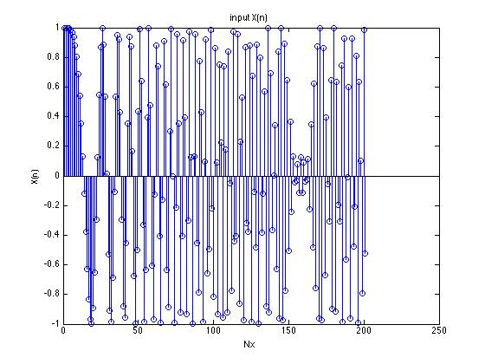

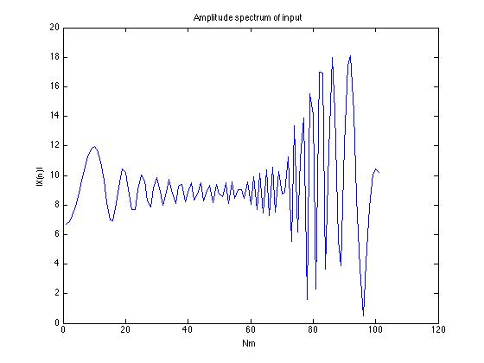

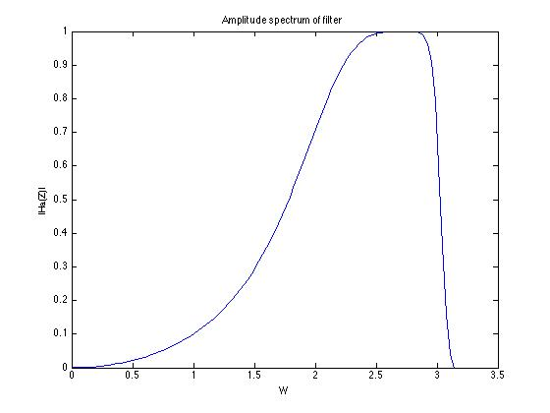

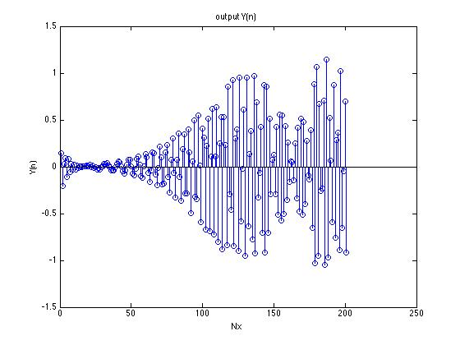

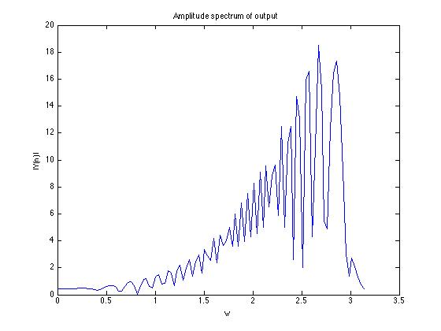

Take home message:

Butterworth filters are characterized by a magnitude response that is maximally flat in the passband and monotonic overall.

Butterworth filters sacrifice rolloff steepness for monotonicity in the passband. We can convert analog butterworth filter into a digital filter by bilinear transformation as shown in the program.